Blood Bank Management System (BBMS)

1. Introduction
Blood Bank Management System (BBMS) is a software system used to manage blood donation, storage, and distribution efficiently. It maintains donor information, blood stock levels, and handles emergency blood requests.
In traditional systems, blood records are maintained manually, which may lead to errors, delays, and difficulty in emergency situations. This system automates the process to ensure quick access, accuracy, and proper tracking of blood availability.
The main focus of this system is tracking blood stock and generating alerts in emergency situations, ensuring timely availability of blood.

2. Objectives
- To automate blood bank operations
- To maintain donor information efficiently
- To track blood stock and availability
- To manage blood donation records
- To handle blood requests quickly
- To generate alerts during emergencies
- To ensure proper inventory control

3. Functional Requirements
The system should be able to:
- Register new donors
- Store donor details (blood group, last donation date)
- Record blood donations
- Maintain blood stock information
- Track blood quantity by group
- Accept blood requests from patients
- Match required blood group with available stock
- Issue blood to recipients
- Generate alerts for low stock or emergency
- Maintain donation and request history

4. Non-Functional Requirements
The system should:
- Provide fast response in emergency situations
- Ensure data accuracy and integrity
- Be secure and protect donor information
- Be user-friendly and easy to operate
- Support backup and recovery
- Be reliable and scalable

5. Use Case Modeling

Actors:
- Donor
- Recipient
- Admin

Main Use Cases:
- Register Donor
- Login
- Donate Blood
- Manage Blood Stock
- Request Blood
- Issue Blood
- Generate Alert
- View Reports

Use Case Diagram:
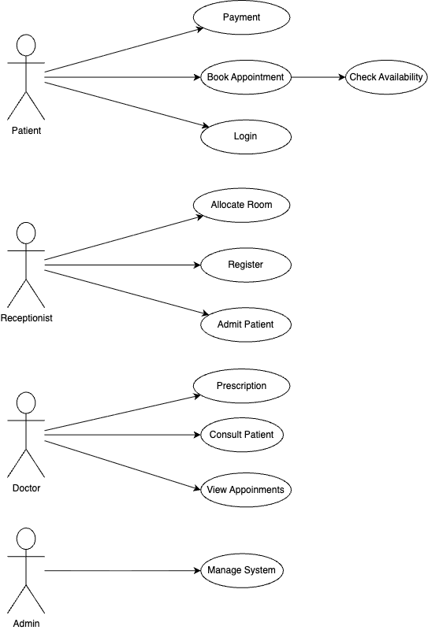

6. Structural Design (Class Diagram)

Main Classes:
- User
- Donor
- Recipient
- BloodStock
- Donation
- BloodRequest
- Alert

Description:
- User is the parent class
- Donor and Recipient inherit from User
- Donor donates blood
- BloodStock stores available blood units
- Donation records donation details
- BloodRequest handles blood requests
- Alert notifies low stock or emergency

Attributes and Methods
User
- Attributes: id, name
- Method: login()
Donor
- Attributes: blood_group, last_donation_date
- Method: donateBlood()
Recipient
- Method: requestBlood()
BloodStock
- Attributes: blood_group, quantity
Donation
- Attributes: donation_date, quantity
BloodRequest
- Attributes: request_date, status
Alert
- Attribute: message

Class Diagram
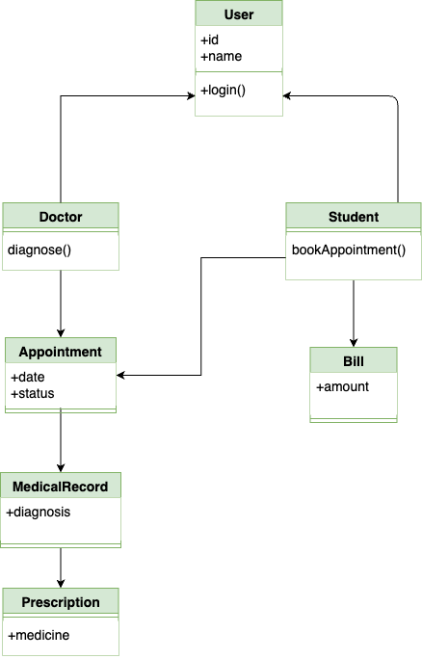

7. Database Design (ER Diagram)

7.1 Entities
- Donor
- Blood_Stock
- Recipient
- Donation
- Blood_Request
- Alert

7.2 Relationships
- Donor donates Blood (Donation)
- Donation updates Blood Stock
- Recipient requests Blood
- Blood Request uses Blood Stock
- Blood Stock generates Alert

7.3 Suggested Primary Keys and Foreign Keys
DONOR
- donor_id (PK)
- name
- blood_group
- phone
- last_donation_date
BLOOD_STOCK
- stock_id (PK)
- blood_group
- quantity
RECIPIENT
- recipient_id (PK)
- name
- required_blood_group
DONATION
- donation_id (PK)
- donor_id (FK)
- stock_id (FK)
- donation_date
- quantity
BLOOD_REQUEST
- request_id (PK)
- recipient_id (FK)
- stock_id (FK)
- request_date
- status
ALERT
- alert_id (PK)
- stock_id (FK)
- message

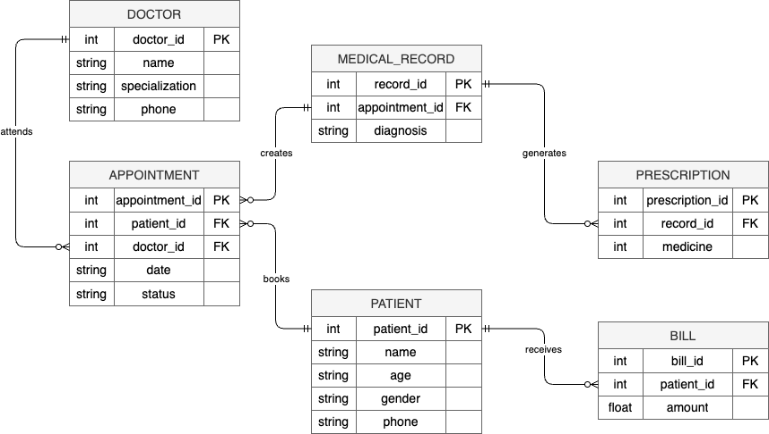

8. Advantages
- Ensures quick access to blood in emergencies
- Reduces manual errors
- Improves inventory management
- Maintains accurate records
- Saves time
- Supports alert system for low stock

9. Limitations
- Requires technical knowledge
- Initial setup cost is high
- System failure may affect emergency services
- Needs proper data security

10. Conclusion
The Blood Bank Management System is an essential solution for managing blood donation and distribution efficiently. It ensures proper tracking of blood stock, quick response to emergency requests, and reliable alert generation. The system improves efficiency, reduces errors, and enhances life-saving operations in healthcare environments.

